The lumped element model (also called lumped parameter model, or lumped component model) simplifies the description of the behaviour of spatially distributed physical systems into a topology (states like stretching/ bending) consisting of discrete entities that approximate the behaviour of the distributed system under certain assumptions.
It is useful in electrical systems (including electronics), mechanical multibody systems, heat transfer, acoustics, etc.
Mathematically speaking, the simplification reduces the state space (eucllidean space like 1d space/2d/3d/nd space) of the system to a finite dimension, and the partial differential equations (PDEs/differential equation based on several variables) of the continuous (infinite-dimensional) time and space model of the physical system into ordinary differential equations (ODEs/ differential equation based on ONE INdependent variable) with a finite number of parameters.
The lumped element model of electronic circuits makes the simplifying assumption that the attributes of the circuit, resistance, capacitance, inductance, and gain, are concentrated into idealized electrical components; resistors, capacitors, and inductors, etc. joined by a network of perfectly conducting wires.

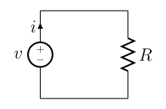

Representation of a lumped model made up of a voltage source and a resistor.

The lumped element model is valid whenever , where denotes the circuit's characteristic length, and denotes the circuit's operating wavelength.

Another way of viewing the validity of the lumped element model is to note that this model ignores the finite time it takes signals to propagate around a circuit. Whenever this propagation time is not significant to the application the lumped element model can be used. This is the case when the propagation time is much less than the period of the signal involved.

The electronic–hydraulic analogy (derisively referred to as the drain-pipe theory by Oliver Lodge) [1] is the most widely used analogy for "electron fluid" in a metal conductor. Since electric current is invisible and the processes at play in electronics are often difficult to demonstrate, the various electronic components are represented by hydraulicequivalents. Electricity (as well as heat) was originally understood to be a kind of fluid, and the names of certain electric quantities (such as current) are derived from hydraulic equivalents. As with all analogies, it demands an intuitive and competent understanding of the baseline paradigms (electronics and hydraulics).

There is no unique paradigm(theory/postulates/concepts) for establishing this analogy. One of the paradigm is a completely enclosed version with pumps providing pressure only and no gravity. This is reminiscent of a circuit diagram with a voltage source shown and the wires actually completing a circuit.

Other paradigms highlight the similarities between equations governing the flow of fluid and the flow of charge. Flow and pressure variables can be calculated in both steady and transient fluid flow situations with the use of the hydraulic ohm analogy.[2][3] Hydraulic ohms are the units of hydraulic impedance, which is defined as the ratio of pressure to volume flow rate. The pressure and volume flow variables are treated as phasors in this definition, so possess a phase as well as magnitude

Hydraulic analogy with horizontal water flow

Voltage, current, and charge
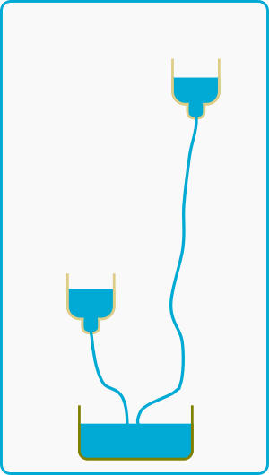
Hydraulic pressure difference
In general, electric potential is equivalent to hydraulic head. This model assumes that the water is flowing horizontally, so that the force of gravity can be ignored. In this case electric potential is equivalent to pressure. The voltage (or voltage drop or potential difference) is a difference in pressure between two points. Electric potential and voltage are usually measured in volts.

Electric current is equivalent to a hydraulic volume flow rate; that is, the volumetric quantity of flowing water over time. Usually measured in amperes.
Electric charge is equivalent to a quantity of water.

Basic circuit elements[edit]
- 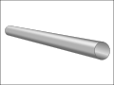
Conducting wire: a simple pipe.

- 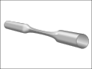
Resistor: a constricted pipe.

- 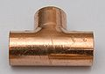
Node in Kirchhoff's junction rule: A pipe teefilled with flowing water.

A relatively wide pipe completely filled with water is equivalent to conducting wire. When comparing to a piece of wire, the pipe should be thought of as having semi-permanent caps on the ends.
Connecting one end of a wire to a circuit is equivalent to un-capping one end of the pipe and attaching it to another pipe. With few exceptions (such as a high-voltage power source), a wire with only one end attached to a circuit will do nothing; the pipe remains capped on the free end, and thus adds nothing to the circuit.

A resistor is equivalent to a constriction in the bore of the pipe which requires more pressure to pass the same amount of water. All pipes have some resistance to flow, just as all wires have some resistance to current.
A node (or junction) in Kirchhoff's junction rule is equivalent to a pipe tee. The net flow of water into a piping tee (filled with water) must equal the net flow out.
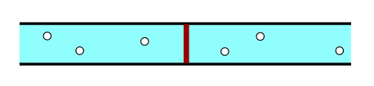

Capacitor: a flexible diaphragm sealed inside a pipe.

A capacitor is equivalent to a tank with one connection at each end and a rubber sheet dividing the tank in two lengthwise[7] (a hydraulic accumulator). When water is forced into one pipe, equal water is simultaneously forced out of the other pipe, yet no water can penetrate the rubber diaphragm. Energy is stored by the stretching of the rubber. As more current flows "through" the capacitor, the back-pressure (voltage) becomes greater, thus current "leads" voltage in a capacitor. As the back-pressure from the stretched rubber approaches the applied pressure, the current becomes less and less. Thus capacitors "filter out" constant pressure differences and slowly varying, low-frequency pressure differences, while allowing rapid changes in pressure to pass through.

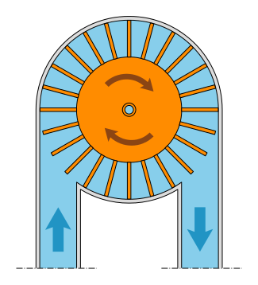

Inductor: a heavy paddle wheel or turbine placed in the current.

An inductor is equivalent to a heavy paddle wheel placed in the current. The mass of the wheel and the size of the blades restrict the water's ability to rapidly change its rate of flow (current) through the wheel due to the effects of inertia, but, given time, a constant flowing stream will pass mostly unimpeded through the wheel, as it turns at the same speed as the water flow. The mass and surface area of the wheel and its blades are analogous to inductance, and friction between its axle and the axle bearings corresponds to the resistance that accompanies any non-superconducting inductor.

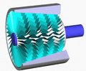

Voltage or currentsource: A dynamic pump with feedback control.

An ideal voltage source (ideal battery) or ideal current source is a dynamic pump with feedback control. A pressure meter on both sides shows that regardless of the current being produced, this kind of pump produces constant pressure difference. If one terminal is kept fixed at ground, another analogy is a large body of water at a high elevation, sufficiently large that the drawn water does not affect the water level.
To create the analog of an ideal current source, use a positive displacement pump: A current meter (little paddle wheel) shows that when this kind of pump is driven at a constant speed, it maintains a constant speed of the little paddle wheel.

